# A8Wb Chi-square test for one population variance

When analysing numerical data, sometimes you need to draw conclusions about the population variance or standard deviation. If we assume that the data are normally distributed, you use the test for the variance or standard deviation defined in equation (8.14) to test whether the population variance or standard deviation is equal to a specified value.

$χ^{2}= \frac{\left(n-1\right)s^{2}}{σ^{2}}$ (W8.1)

Where n = sample size, s2 = sample variance, and σ2 is the hypothesised population variance. The test statistic χ2 follows a chi-square distribution with n – 1 degrees of freedom. The assumptions for the **chi-square test for variance** are as follows:

1. Sample randomly selected from the population.
2. Population must be normally distributed.
3. Sample data values must be independent.

**Example W8.1**

A small enterprise sells bird seed in 1 kg bags. The bags historically have a known population standard deviation which is equal to 30 grams and the bag weights are normally distributed. The company is interested in checking, as part of the quality control process, that this is not above 30 grams. To enable this question to be answered the company has collected a sample of 40 bags and calculated the sample standard deviation to be 32.5 grams. Conduct an appropriate hypothesis test to test if the population standard deviation is greater than 30g. The hypothesis test would be as follows:

H0: σ2 = 302 = 900

H1: σ2 > 900

**Excel solution**

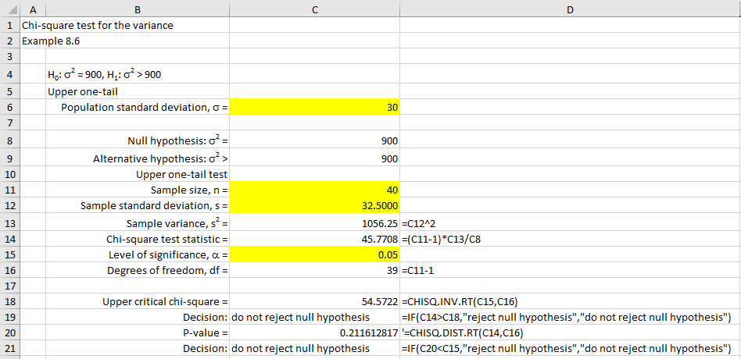

Figure W8.1

**Excel solution**

Population standard deviation, s = Cell C6 Value

Null hypothesis: σ2 = Cell C8 Formula:=C4^2

Alternative hypothesis: σ2 > Cell C9 Formula:=C6

Upper one-tail test

Sample size, n = Cell C11 Value

Sample standard deviation, s = Cell C12 Value

Sample variance, s2 = Cell C13 Formula:=C12^2

Chi-square test statistic = Cell C14 Formula:=(C12-1)*C1/C8

Level of significance, α = Cell C15 Value

Degrees of freedom, df = Cell C16 Formula:=C11-1

Upper critical chi-square = Cell C18 Formula:=CHISQ.INV.RT(C15,C16)

Decision: Cell C19

Formula: =IF(C14>C18, "Reject null hypothesis", or "Do not reject null hypothesis")

P-value = Cell C20 =CHISQ.DIST.RT(C14,C16)

Decision: Cell C21

Formula: =IF(C20<C15, "Reject null hypothesis", or "Do not reject null hypothesis")

The five-step procedure to conduct this test progresses as follows.

**Step 1 - State hypothesis**

H0: σ2 = 302 = 900

H1: σ2 > 900

Upper one-tail test

**Step 2 - Select test**

Comparing sample variance against the population variance. Assumed data is normally distributed. Chi-square variance test.

**Step 3 - Set the level of significance** (  ) (see Cell C15)

**Step 4 - Extract relevant statistic**

Given σ = 30 (Cell C4), n = 40 (Cell C10), s = 32.5 (Cell C11)

From equation (8.15): χ2 = 45.77 (Cell C13)

Given we have an upper one tail test, then the critical chi-square value = 54.57 (Cell C19), and corresponding p-value = 0.2116 (Cell C22).

**Step 5 - Make decision**

Given χ2 = 45.77 < Critical chi-square value = 54.57, then fail to reject the null hypothesis. Alternatively, you will have the same decision if you compare the p-value with your chosen significance level (p-value = 0.2116 > significance level = 0.05).

You conclude that there is insufficient evidence that the population standard deviation is greater than 30 grams.